The poetry of algorithm becomes art at New York gallery.

Poet Marcos de la Fuente presents an AI-based performance at The Mynt Gallery, in Highline Nine.

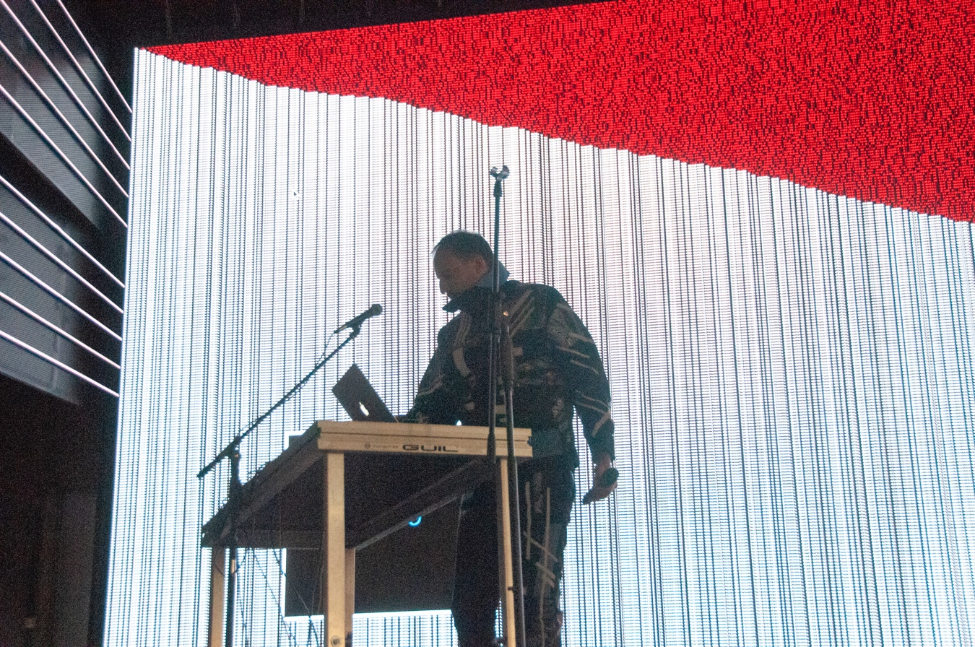

Can machines write poetry?

Can AI thrill like a poet?

What is the distance between the human and AI?

Poet and artist Marcos de la Fuente, in collaboration with quantum engineer Ismael Faro and code programmer Mariel Martínez, presents *The Poet vs. The Machine*, a show of generative art and live poetry, with live music and AI interaction.

This is a poetic AI, executed by a digital twin of the artist Marcos de la Fuente, in order to generate poetry in the same manner that the poet himself does. At the same time, it dialogues in real time with the audience and with the creator himself, in a generative poetry exercise that is visually manifested on the big screen.

The starting point is the bilingual poems New York-based Marcos de la Fuente. These are poems that talk about the new virtual worlds and the evolution of art towards digital. Los Angeles-based sound architect Alec Ekvall created the music.

The show is experiential poetry represented with visuals that complement the recitation with live music. The visuals are generated by the machine through algorithms that are adjusted to each poem and that will learn, grow and modulate show after show.

In addition to the live show, a website will be presented. Through it, the public can also interact with AI., writing words or entire verses to be completed by the poet's digital twin.

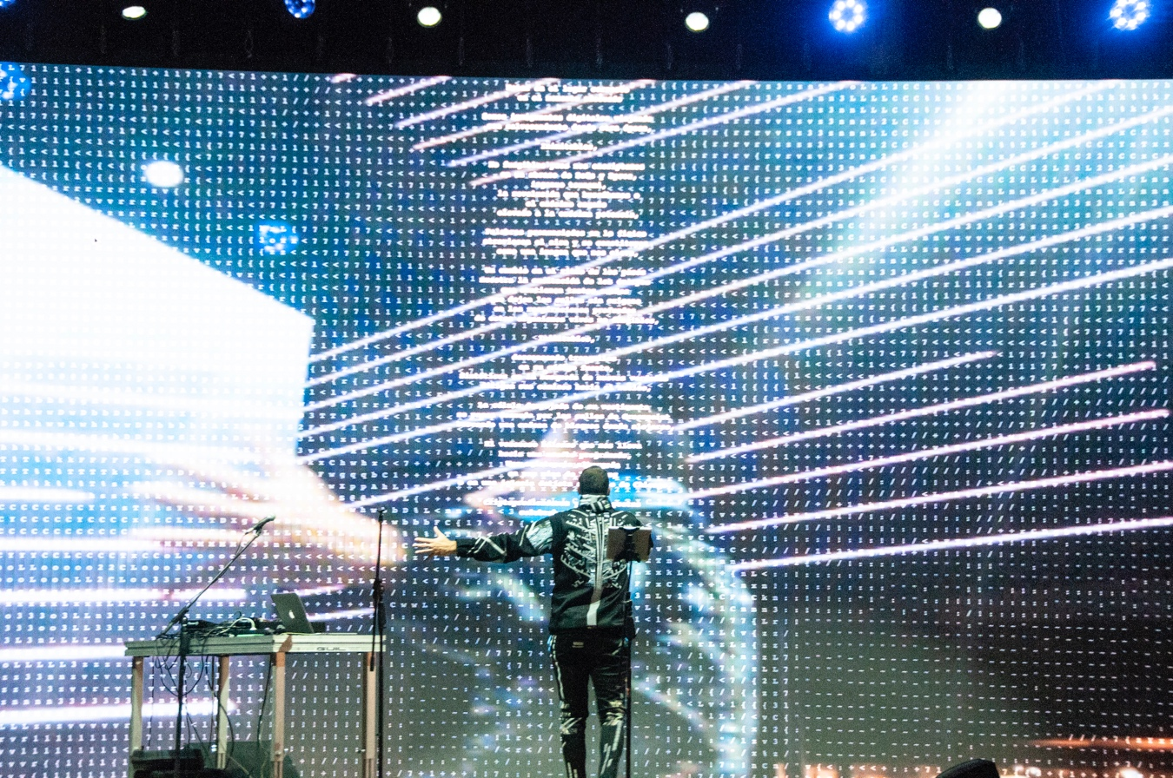

**The Poet vs. The Machine**

A 3.0 digital live performance by Marcos de la Fuente

November Saturday 20, 7 PM

*The Mynt Gallery*, 507 W 27th St, Chelsea, New York

Presented by Ismael Faro, Distinguished Engineer at IBM, and Mariel Martínez

POETRY AND PERFORMANCE: Marcos de Fuente

CREATION I.A. DIGITAL TWIN AND WEB: Mariel Martínez and Ismael Faro

STYLING: La Canalla Studio

GRAPHIC DESIGN: Vanesa Álvarez

MUSIC: Alec Ekvall